### A STUDY ON TREND ANALYSIS OF AMAZON SALES IN INDIA

***Submitted***

*In partial fulfillment of the requirements for the award of the degree of*

### MASTER OF BUSINESS ADMINISTRATION (BUSINESS DATA ANALYTICS)

**In**

### SCHOOL OF MANAGEMENT STUDIES BY

**PUCHAKAYALA SAI NANDINI [Regd.No: 230A1E0443]**

**Under the supervision and guidance of**

**Dr. D. JAKIR HUSSAIN MBA., Ph. D., MSc (Psy) ASSISTANT PROFESSOR (A)**



**SCHOOL OF MANAGEMENT STUDIES JAWAHARLAL NEHRU TECHNOLOGICAL UNIVERSITY**

**ANANTAPUR ANANTAPURAMU-515002 2023-2025**

**JAWAHARLAL NEHRU TECHNOLOGICAL UNIVERSITY ANANTAPUR - 515002**

**SCHOOL OF MANAGEMENT STUDIES**

**BONAFIDE CERTIFICATE**

This is to certify that the project report, entitled **‘‘A STUDY ON TREND ANALYSIS OF AMAZON SALES IN INDIA’’** submitted to the **JAWAHARLAL NEHRU TECHNOLOGICAL**

**UNIVERSITY**, **ANANTAPUR** in Partial fulfillment of the requirements for the award of the Degree of **MASTER OF BUSINESS ADMINISTRATION (BDA)** is a record of original research work done by **PUCHAKAYALA SAI NANDINI**, during the period 25th January 2025 to 5th March 2025 of his study in the **MASTER OF BUSINESS ADMINISTATION** at **JAWAHARLAL**

**NEHRU TECHNOLOGICAL UNIIVERSITY ANANTAPUR**, under the supervision and guidance of **Dr.D.JAKIR HUSSAIN** and the training report has not formed the basis for the award of any Degree / Diploma / Associate ship / Fellowship or other similar title to any candidate of any University.

Internal guide Head

JNTUA SMS Viva voice

examination held on:

**Internal Examiner External Examiner**

Date:

Place: ANANTAPURAMU

**A STUDY ON TREND ANALYSIS OF AMAZON SALES IN INDIA**

ORIGINALITY REPORT

7%

SIMILARITY INDEX

5%

INTERNET SOURCES

2%

PUBLICATION S

3%

STUDENT PAPERS

PRIMARY SOURCES

[www.coursehero.com](http://www.coursehero.com/) 1

1

Internet Source

%

2 Junjie, Zhu. "Launch of the e-Commerce in the Ruizhu Jewelry Company",

1

ISCTE - Instituto Universitario de Lisboa (Portugal), 2024 %

Publication

Submitted to Chandigarh University

3

Student Paper

4 "Anticipating Future Business Trends: Navigating Artificial Intelligence Innovations",

Springer Science and Business Media LLC, 2024

Publication

Submitted to University of Houston System

5 Student Paper

dspace.christcollegeijk.edu.in:8080

6

Internet Source

[www.iccr.org](http://www.iccr.org/)

7

Internet Source

1%

<1%

<1%

<1%

<1%

iii

### DECLARATION

I hereby declare that the project report entitled **‘‘A STUDY ON TREND ANALYSIS OF AMAZON SALES IN INDIA ’’** is record of independent research work and is carried out by me during the period of my study, submitted to **JAWAHARLAL NEHRU TECHNOLOGICAL UNIVERSITY, ANANTAPUR,** under the guidance of **Dr.D.JAKIR HUSSAIN** Assistant professor in School of Management Studies, **JAWAHARLAL NEHRU TECHNOLOGICAL UNIVERSITY** for the award of the degree of **MASTER OF BUSINESS ADMINISTRATION (BDA) (2023-2025)** is my original work, has not been submitted to any other university for the award of any degree.

Date: **PUCHAKAYALA SAI NANDINI**

Place: ANANTAPUR **230A1E0443**

### ACKNOWLEDGEMENT

I express my sincere gratitude to **Dr. B. CHANDRA MOHAN REDDY, ME., Ph.D., MIE., MISTE., Professor &** Head of the School of Management Studies for his constant support and encouragement.

I would never forget to thank Dr.D.**JAKIR HUSSAIN,** Assistant Professor at School of Management Studies for his valuable guidance in preparation of this project work.

I also thank our faculty members **Dr. B.C. LAKSHMANNA, Dr. P. JAYARAMI REDDY, Dr.P.BASAIAH, Dr. K. SRILATHA, Dr. P. VISWANATH, Dr. P. SRAVAN KUMAR,** for their

keen interest and constructive criticism, which played vital role in completing my project on time.

I would like to express my heartfelt thanks to Amazon Company and all the respondents who gave valuable information to me.

I also extend my thanks to all my family members and my friends who helped me in completing this project work successfully.

**PUCHAKAYALA SAI NANDINI 230A1E0443**

**ABSTRACT**

India's booming e-commerce sector has established Amazon as a prominent market leader, significantly shaping consumer buying habits and transforming the retail landscape. This study presents a detailed trend analysis of Amazon's sales performance within the Indian market.

identifying patterns in revenue growth, product demand, seasonal fluctuations, and the impact of strategic sales events. By leveraging historical sales data, the research explores how factors such as pricing strategies, customer preferences, and external economic conditions shape Amazon’s performance. Additionally, the study assesses the role of technological advancements, logistical efficiency, and competitive market forces in driving sales trends.

The findings from this analysis provide important insights for businesses, marketers, and policymakers aiming to navigate and respond to the changing dynamics of India’s e-commerce landscape.

### TABLE OF CONTENTS

|  |  |  |
| --- | --- | --- |
| **S.NO** | **PARTICULARS** | **PAGE NO** |
| **1** | **INTRODUCTION** | **1-6** |
| **2** | **INDUSTRY PROFILE** | **8-9** |
| **COMPANY PROFILE** | **10-15** |
| **3** | **RESEARCH METHODOLOGY** | **16-22** |
| **3.1 NEED OF THE STUDY** | **17** |
| **3.2 SCOPE OF THE STUDY** | **18** |
| **3.3 OBJECTIVES OF THE STUDY** | **19** |
| **3.4 SOURCE OF THE DATA** | **20** |
| **3.5 TOOLS AND TECHNIQUES** | **22** |
| **3.6 LIMITATIONS OF THE STUDY** | **23** |
| **4** | **DATA ANALYSIS AND INTERPRETATION** | **24-43** |
| **4.1 UNDERSTANDING THE DATA** | **24** |
| **4.2 PREPROSSING** | **25** |
| **4.3 EXTRACTING DATA** | **29** |
| **4.4 ANALYSIS &** | **30** |
| **4.5 VISUALIZATION** | **43** |
| **5** | **FINDINGS** | **45** |
| **SUGGESTIONS** | **46** |
| **CONCLUSION** | **47** |
| **6** | **BIBLIOGRAPHY** | **48** |

**TABLE OF FIGURES**

|  |  |  |
| --- | --- | --- |
| **GRAPH NO** | **PARTICULARS** | **PAGE NO** |
| 4.1 | TOTAL SALES BY DISTRIC | 30-32 |
| 4.2 | TOTAL SALES BY STATES | 32-33 |
| 4.3 | TOTAL PROFIT BY DISTRIC | 34-35 |
| 4.4 | TOTAL PROFIT BY STATES | 35-36 |
| 4.5 | TOP SELLING PRODUCT BY TOTAL UNITS SOLD | 37-38 |
| 4.6 | MONTH WISE SALES TREND | 39-40 |
| 4.7 | YEAR WISE SALES TREND | 40-41 |
| 4.8 | YEARLY-MONTHLY SALES TREND | 42-43 |

# CHAPTER – I INTRODUCTION

#### INTRODUCTION:

The importance of sales management as a function is more evident than ever in today's fast paced global market. With the increasing competition across all sectors, businesses have to go for innovative distribution techniques to reduce operational costs and enhance the overall profitability. Sales management assists in this, giving strategies to make the most of revenue streams and improve responsiveness in the market. This project is an analysis of sales trends for amazon, A major force in the international e-commerce industry companies to understand sales trend and building potential key sales trends and providing actionable insights to help improve operational efficiency and profitability.

Amazon:‖Work Hard. Have Fun. Make History.‖ A Global E-Commerce Power house

Amazon incorporated, Established by Jeff Bezos in the year 1994, has evolved Starting as a basic online bookstore and evolving into a worldwide e-commerce leader. Initially launched as a digital platform for books, amazon's rapid expansion has turned it into a comprehensive global enterprise, Providing diverse services and products such as cloud solutions, AI technologies, streaming content, and logistics operations

##### Evolutionand Expansion:

Amazon's transformation from a start up in Bezos’s garage to a global leader in online retail reflects sits innovative strategy and strategic growth. The company's early success was driven by its focus on providing a broad selection of books at competitive prices through a user-friendly online experience. This commitment to customer satisfaction set the stage for Amazon's expansion into other categories such as electronics, clothing, and house hold goods. "In the early 2000s, Amazon began expanding its operations, introducing Amazon Web Services (AWS) in 2006—a move that transformed the cloud computing industry and emerged as a significant contributor to the company's

revenue The acquisition of Whole Foods Market in 2017 marked Amazon's strategic entry into physical retail, merging online and offline shopping experiences.

##### Technological Innovations :

Amazon's success is deeply tied to its relentless pursuit of technological advancement. The company has introduced significant innovations in e-commerce technology, such as one-click purchasing, personalized recommendations, and sophisticated search

algorithms. Funding directed toward AI and machine learning technologies have transformed online shopping by improving recommendation accuracy and optimizing inventory management. Amazon Echo and the Alexa voice assistant exemplify the company’s prowess in consumer electronics, setting new standards for smart home devices and integrating voice technology into everyday life.

##### Business Modeland Strategies:

Amazon's success is rooted in its unique business model, which features a customer-centric approach, a vast product range, and competitive pricing. The Prime membership program is a key example, Delivering value through free shipping, limited-time deals, and access to media streaming which not only generates recurring revenue but also strengthens customer loyalty. Amazon’s marketplace platform allows third-party sellers to reach a global audience, enhancing the company’s product diversity and revenue while creating a vibrant ecosystem of continuous growth and innovation.

##### Customer-Centric Approach:

Amazon’s focus is on delivering an outstanding customer experience through a user-friendly website, a wide array of products, competitive pricing, and quick shipping. The Prime membership program highlights this commitment Providing advantages including free delivery, special member offers, and digital streaming services

##### MarketplacePlatform:

Amazon’s marketplace enables third-party sellers to list products, broadening the available product range and creating a competitive environment. This benefits sellers by providing access to Amazon’s extensive customer base and benefit Amazon through increased product diversity and seller fees.

##### Recurring Service Offering :

In addition to Prime, Amazon provides a range of subscription-based offerings such as Amazon Music Unlimited and Amazon Fresh. These services help generate consistent revenue while enhancing customer loyalty and interaction

##### Global Reachand Local Adaptation:

Amazon’s international presence is bolstered by localized operations that cater to specific markets.

The company adapts its offerings and services to fit

local preferences and regulations, demonstrating its ability to operate effectively across diverse globa l markets.

Amazon’s impact extends beyond e-commerce, influencing many aspects of the global economy and society. Its logistical infrastructure, including an extensive network of fulfillment centers and delivery services, has set new standards for efficiency and speed, reshaping consumer expectations for delivery times and convenience. Additionally, Amazon’s global reach affects international trade and

retail practices, showcasing its strategic versatility. However, its dominance also raises concerns abo ut market concentration, competitive practices, and the effects on small businesses.

##### RetailIndustry:

Amazon’s impact on digital retail has reshaped customer expectations and intensified market competition, pushing conventional retailers to adjust by integrating both online and physical shopping experiences.

##### Technology Sector:

Amazon’s advancements in cloud computing, AI, and smart devices have Positioned it as a key player in the tech sector, with AWS driving of the growth of cloud services and influencing other technology companies.

##### Employmentand LaborPractices:

Amazon’s large-scale operations have created many job opportunities but also led to debates over labor practices and working conditions. The company has faced scrutiny regarding warehouse conditions, wages, and labor rights.

##### Supply Chain and Logistics:

Through advancements in logistics and supply chain operations, Amazon has established new industry standards. Its investments in delivery infrastructure and strategic collaborations have enhanced the speed and efficiency of order fulfillment

##### Ethicaland Social Considerations

As a major global corporation, Amazon faces scrutiny over its ethical and social responsibilities. Concerns include labor conditions, environmental sustainability, and data privacy. The company has undertaken efforts to address these issues, such as improving worker conditions and committing to reducing carbon emissions, reflecting its recognition of broader societal responsibilities.

##### Environmental Impact

Amazon’s operations have a substantial environmental footprint, including carbon emissions from transportation and logistics. Amazon has pledged to reach net-zero carbon emissions by 2040 and is actively investing in renewable energy initiatives.

##### Data Privacyand Security

The vast amount of data collected from customers raises concerns about privacy and security. While Amazon has implemented measures to protect user information, data breaches and privacy issues remain a concern.

##### CorporateSocialResponsibility

Amazon has engaged in various initiatives to address social and community issues, including charitable contributions and local community support. However, these efforts are often evaluated in the context of the company's overall societal impact.

##### Future Prospectsand Challenges

In the future, Amazon's growth path will be shaped by emerging technologies, evolving customer expectations, and shifts in regulatory frameworks. Its emphasis on innovation and expanding its

range of offerings supports ongoing expansion, although the company will need to address challenges such as increased competition, market maturity, and tightening regulations.

##### Innovationand Technology:

Amazon's ability to maintain a competitive edge will depend on continued innovation and technological advancements. Progress in AI, robotics, and logistics is likely to drive future growth.

##### Regulatory Environment

The company’s global operations face regulatory scrutiny and potential changes in laws related to antitrust, labor practices, and data privacy. Successfully navigating these challenges will be crucial for Amazon’s ongoing success.

##### Market Competition:

The e-commerce sector is increasingly competitive, with major players like Alabama, Wal-Mart, and Microsoft competing for market share. Amazon must adapt to evolving market conditions and consumer preferences to retain its leadership position.

##### SustainabilityandEthical Practices:

Addressing environmental and social concerns will be essential for Amazon’s long-term success and reputation. The company’s commitment to sustainability and ethical practices will impact its relationships with customers, employees, and stakeholders.

#### MEANING :

The project **"A Study on Trend Analysis of Amazon Sales in India"** simply means **examining how Amazon's sales in India have changed over time**. It looks at patterns, growth, and factors that affect sales, such as discounts, festivals, and customer preferences. The goal is to understand past trends and predict future sales performance.

#### DEFINITION

Amazon sales trend analysis refers to the process of examining and interpreting patterns, fluctuations, and changes in sales data on amazon over a specific period of time. The goal is to identify key trends, understand customer behavior, forecast future sales, and optimize product listings or marketing strategies.

Amazon sales over time to see if your sales are going up, down, or staying the same. This helps you understand how well your products are doing and make better decisions about your business.

## CHAPTER – II INDUSTRY PROFILE

**& COMPANY PROFILE**

s

#### INDUSTRY PROFILE

##### E-Commerce Industry Profile

The e-commerce sector has swiftly emerged as a major force in the global economy, transforming how consumers and businesses connect and conduct transactions. Defined as the online exchange of goods and services, e-commerce has surged in popularity due to advancements in technology, wider internet access, and consumers' increasing demand for convenience. The adoption of digital payment systems, artificial intelligence, and streamlined logistics has further fueled the industry's growth, continually reshaping the landscape of retail and commerce across the world.

##### Market Size and Growth Trends

Over the past decade, the global e-commerce industry has witnessed remarkable growth, driven by factors such as the widespread use of smart phones, improved internet connectivity, and enhanced security in online transactions. Major markets like the United States, China, India, along with regions such as Europe and Southeast Asia, have become key players in this evolving landscape.

The outbreak of COVID-19 further accelerated this growth, as restrictions on physical retail led consumers to rely heavily on online shopping. This shift resulted in a significant increase in demand for digital marketplaces across sectors like fashion, electronics, groceries, and digital services. Additionally, mobile commerce (m- commerce) has seen rapid adoption, with a growing number of users choosing to make purchases through smart phones and dedicated mobile apps

##### Key Drivers of Growth

Several factors contribute to the rapid growth of the e-commerce industry. First, technological advancements such as AI-driven recommendations, catboats, and augmented reality (AR) have enhanced user experience, making online shopping more interactive and personalized. Second, improved logistics and supply chain management systems have enabled faster and more reliable delivery services, increasing consumer trust in e-commerce platforms. Thirdly, the use of diverse digital payment options such as credit cards, mobile wallets, UPI, and crypto currencies has

made online transactions more convenient and secure Additionally, the convenience of doorstep delivery, competitive pricing, and a wider range of product availability has attracted a broad consumer base. Social media platforms have also played a crucial role in e-commerce expansion, with businesses leveraging digital marketing, influencer collaborations, and targeted advertisements to drive sales.

##### Key Players in the Industry:

The e-commerce industry is dominated by several key players, each contributing to its overall growth. Amazon, the world’s largest e-commerce platform, has set benchmarks in logistics, cloud computing, and customer service. Alibaba, based in China, has built a vast ecosystem of online retail, cloud computing, and financial services. Other notable companies include eBay, Wal-Mart, Shopify, and emerging Direct-to-consumer (DTC) brands are challenging conventional retail structures and reshaping the way products reach customers

Regional players such as Flip kart in India, Mercado Libre in Latin America, and Rakuten in Japan have successfully built strong local market presences. Additionally, niche e-commerce platforms specializing in specific product categories, such as fashion, electronics, or groceries, have also carved out their market segments.

##### Future Trends and Opportunities:

Several emerging trends are shaping the future landscape of e-commerce. One key development is the growing use of artificial intelligence to deliver personalized shopping experiences, with businesses leveraging machine learning to analyze user behavior and offer customized product suggestions. Additionally, the integration of blockchain technology is gaining momentum, aiming to improve the security, transparency, and reliability of digital transactions.

Sustainability is also becoming a central concern within the industry. More consumers now prioritize environmentally friendly packaging, ethically sourced products, and sustainable business practices. In response, companies are adopting eco-conscious supply chain strategies and taking steps to minimize their environmental impact.

#### COMPANY PROFILE :

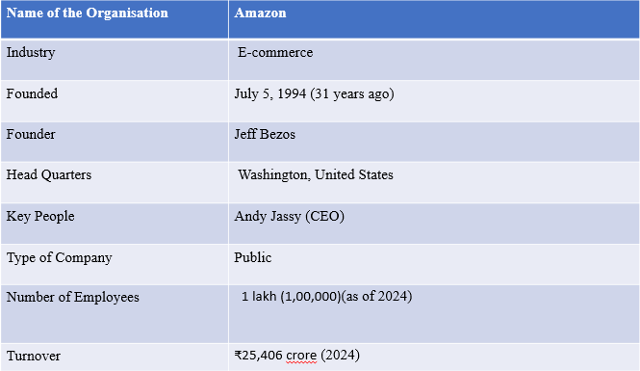

**COMPANY PROFILE:**

**Global Overview**

**Amazon.com, Inc.** is a global technology and e-commerce giant headquartered in Seattle, Washington, USA. It was founded by **Jeff Bezos** on **July 5, 1994**, originally as an online bookstore. Over the years, it evolved into a diversified technology enterprise operating in various sectors, including retail, cloud computing, artificial intelligence (AI), digital streaming, and logistics. Amazon is often recognized as one of the ―Big Five‖ tech companies, alongside Google, Apple, Microsoft, and Meta.

Amazon operates in **over 200 countries and territories**, with major marketplaces in:

* United States
* Canada
* United Kingdom
* Germany
* India
* Japan
* Australia
* France, Italy, Spain, Netherlands, and more.

Each regional website (e.g., Amazon.in, Amazon.co.uk) is localized in terms of product offering, language, logistics, and customer service.

##### Vision & Mission :

* **Vision Statement:** "To be Earth’s most customer-centric company, where customers can find and discover anything they might want to buy online."
* **Mission Statement:** "We strive to offer our customers the lowest possible prices, the best available selection, and the utmost convenience."

**Key Global Business Segments:**

|  |  |
| --- | --- |
| **Segment** | **Description** |
| **E-Commerce Marketplace** | A wide variety of products including books, electronics, apparel, groceries, etc. |
| **Amazon Web Services (AWS)** | The world's most comprehensive and broadly adopted cloud platform. |
| **Amazon Prime** | Membership program offering fast delivery, Prime Video, Prime Music, and other exclusive benefits. |
| **Amazon Devices** | Echo (Alexa), Fire TV, Kindle, and smart home products. |
| **Digital Content** | Prime Video, Amazon Music, Audible (audiobooks), and Kindle eBooks. |
| **Logistics & Supply Chain** | Amazon has its own global delivery and fulfillment network. |

**Amazon in India**

Entry into Indian Market:

Amazon launched Amazon.in in June 2013. India was seen as a high-growth market with increasing internet penetration, a growing middle class, and rising smartphone usage.

**Amazon’s Business in India Includes:**

* **Amazon.in**: A localized e-commerce platform offering millions of products across multiple categories.
* **Amazon Prime India**: Launched in 2016, Prime offers free one/two-day delivery, Prime Video, and Prime Music.
* **Amazon Pay**: A digital payment platform offering UPI, mobile recharge, bill payments, and partnerships with merchants
* **Amazon Fresh & Pantry**: Grocery delivery services focusing on essential household items and fresh produce.
* **Amazon Business**: A platform tailored for B2B needs, allowing bulk buying and business-exclusive pricing.
* **Kindle India & Audible**: Digital book and audiobook services tailored for the Indian audience.
* **Local Shops on Amazon**: Enables offline retailers to expand online.

1. **Investment and Expansion in India**

Amazon has committed over $6.5 billion in investments in India, focusing on:

* + Building fulfillment centers and delivery stations across the country (more than 60+ fulfillment centers).
  + Enhancing infrastructure, including tech hubs in cities like Bengaluru and Hyderabad.
  + Supporting MSMEs through digitization programs like Amazon Saheli (women entrepreneurs) and Amazon Karigar (handicrafts).
  + Developing advanced technologies for the Indian market, including localized Alexa voice experiences.
  + Expanding Amazon Web Services (AWS) with large-scale data centers India.

1. **Employment & Ecosystem Impact**
   * Direct Employment: Over 100,000 employees in India.
   * Indirect Employment: Supports lakhs of delivery associates, third-party sellers, logistics workers, and service partners.
   * Sellers on Amazon India: More than 1 million small and medium businesses (SMBs) sell through Amazon.in.

**Customer-Centric Approach**

Amazon’s guiding principle is **"Customer Obsession."** Key features:

* + One-click ordering
  + Hassle-free returns and refunds
  + Secure digital payments
  + Multiple language support (including Hindi, Tamil, Kannada)
  + Voice shopping using Alexa

Customer satisfaction metrics like **Net Promoter Score (NPS)** are actively used to track experience quality.

1. **Technological Innovations in India**
   * Use of machine learning and AI for personalized recommendations and fraud detection.
   * Voice commerce through Alexa in Indian languages.
   * Launch of Amazon Air (2023) to expedite delivery through air cargo services— India became the first Asian country to launch it.
   * Investment in green delivery – introduction of electric vehicles (EVs) to reduce the carbon footprint.
2. **Competitive Landscape in India**

Amazon competes in a rapidly evolving market with strong domestic and international players:

* + Flipkart (Walmart-owned)
  + Reliance Retail / JioMart
  + Meesho (social commerce)
  + Snapdeal, Myntra, BigBasket (groceries), Tata Neu, and others

**Competition**

|  |  |
| --- | --- |
| **Global** | **India** |
| Walmart, Alibaba, eBay, Apple | Flipkart (Walmart), Reliance JioMart, Meesho, Tata Neu, BigBasket |

1. **Key Challenges in India :**
   * **Regulatory Hurdles**: Restrictions on foreign direct investment (FDI) in e- commerce limit how Amazon can sell and manage inventory.
   * **Price Competition**: Aggressive pricing and discounting from competitors
   * **Infrastructure Limitations:** Challenges in delivering to rural and remote areas.
   * **Data Privacy & Localization**: Complying with India’s evolving data laws and consumer protection norms.

**Sustainability & Social Responsibility**

Amazon has pledged to become **net-zero carbon by 2040** under its **Climate Pledge**. Efforts include:

* + Deployment of **electric delivery vehicles**
  + Investing in **renewable energy projects**
  + Plastic-free packaging and **eco-friendly materials**
  + Supporting rural development through e-commerce access
  + Promoting **local artisans and small sellers**

1. **Future Outlook**

Amazon continues to focus on:

* + • Expanding into **Tier 2 & Tier 3 cities in India**
  + • Promoting **Made-in-India** sellers globally
  + • Growing **Amazon Fresh** for online groceries
  + • Scaling up **Amazon Air** in India and APAC
  + • Supporting **1 crore MSMEs by 2025** in India
  + • Continued development of **sustainable and smart delivery systems**

## CHAPTER - III RESEARCH METHODOLOGY

#### NEED OF THE STUDY

* + - The analysis of Amazon sales trends aims to understand how factors like:
      * Product type
      * Time period
      * Sales and profits
    - •This study is identify sales patterns, improve delivery methods, and manage sales better, leading to cost savings and higher profits of Amazon sales.

#### SCOPE OF THE STUDY

* + - The study conduct in depth analysis of **amazon’s** sales data.
    - The study identifies the top selling products and evaluates profitability in different regions.

#### OBJECTIVES OF THE STUDY

* + - To examine monthly and yearly sales trends of amazon in India
    - To evaluate the profits by Districts/States.
    - To identify top-selling product by Districts/States.

#### RESEARCH METHODOLOGY

* This research is primarily based on secondary data.
* The secondary data has been gathered from websites, articles, and other relevant online sources.

**Website:**

[https://www.Scribd.Com/document/770538685/23mba20195-intership-project-report](https://www.scribd.com/document/770538685/23mba20195-intership-project-report)

#### TOOLS AND TECHNIQUES

* + - **Tools**
* Python with Jupiter notebook
  + - **Techniques**
* Descriptive analysis

#### LIMITATIONS OF THE STUDY

* The scope of the study is restricted to Amazon Pvt. Ltd.
* The study is limited to 2 years of data i.e., 2023-2024 to 2024-2025

## CHAPTER – IV

**DATA ANALYSIS & INTERPRETATION**

#### DATA ANALYSIS AND INTERPRETATION

##### Understanding The Data

**Importing the libraries**

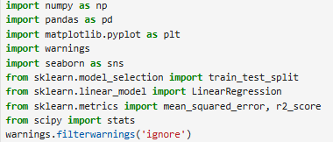

**Reading the file**



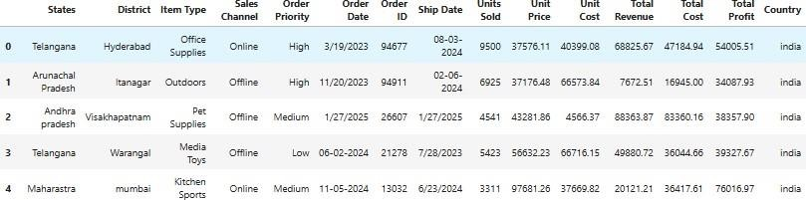

**Preprocessing**

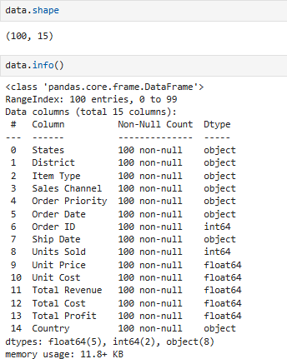

**Converting the order date into unified format**

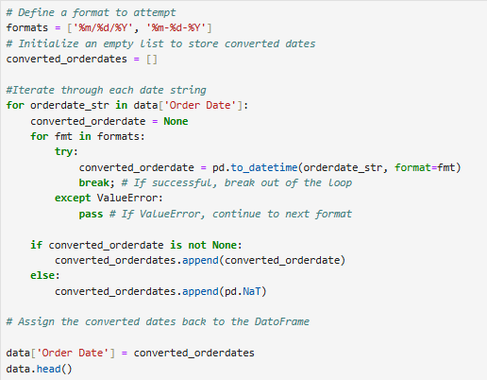

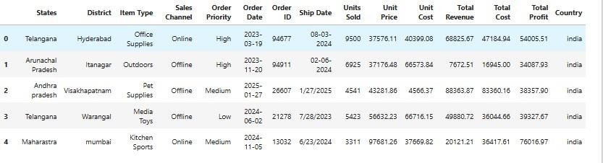

**Converting the ship date into unified format**

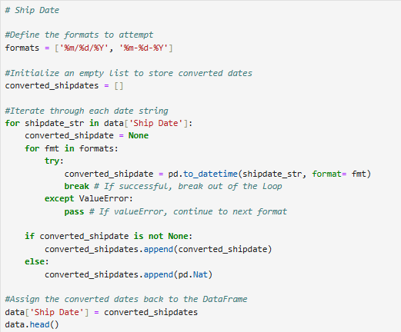

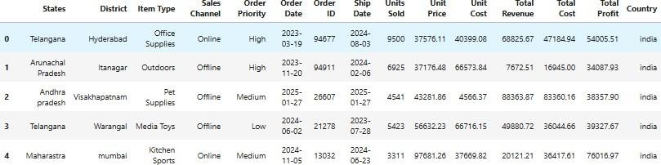

**Checking the uniqueness**

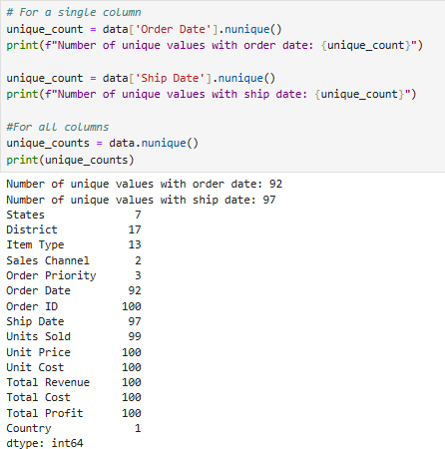

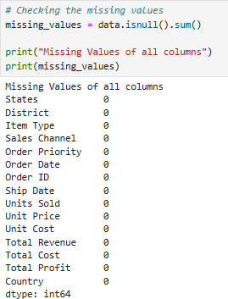

**Extracting the data**

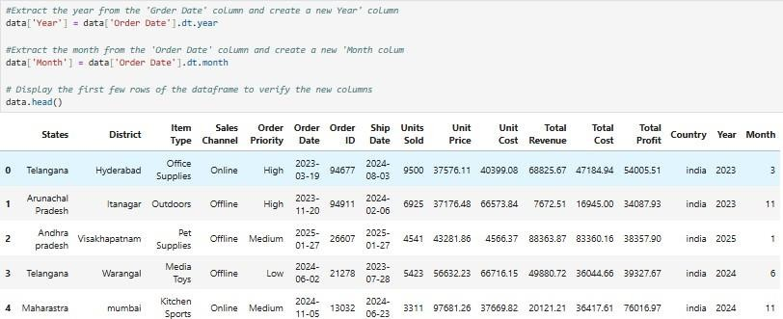

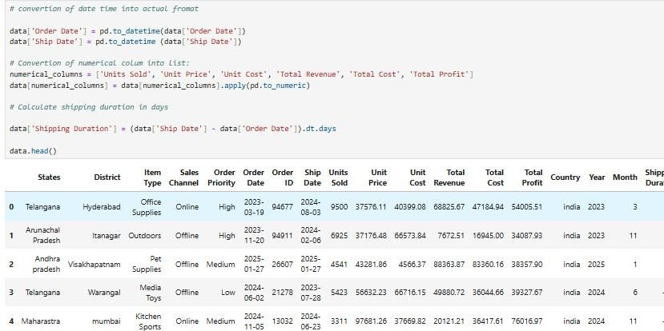

**Analysis & Visualizations**

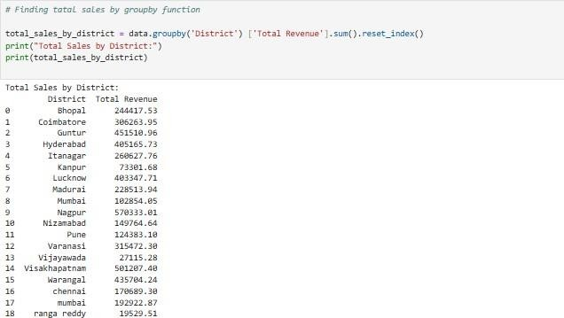

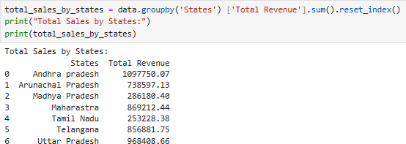

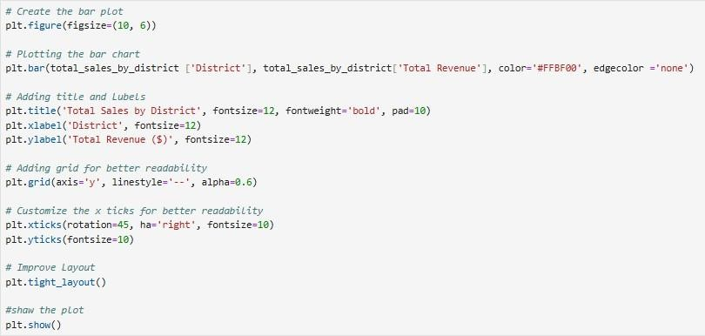

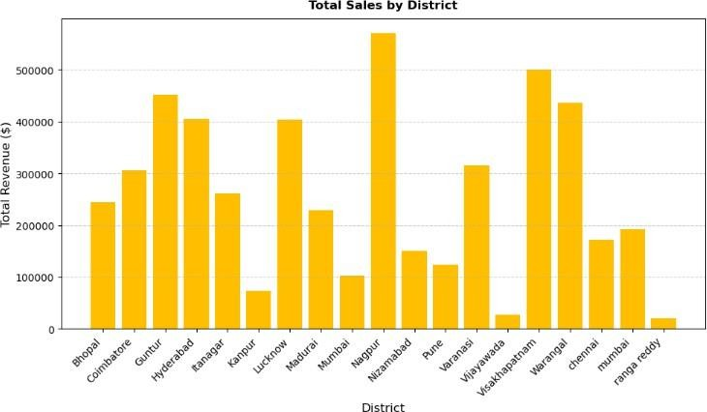

#### INTERPETATION

This bar graph shows the total sales in dollars for different districts. **Nazamabad** has the highest sales. **Ranga reddy** has the lowest sales. Many districts have moderate sales, but there's a big range between the highest and lowest.

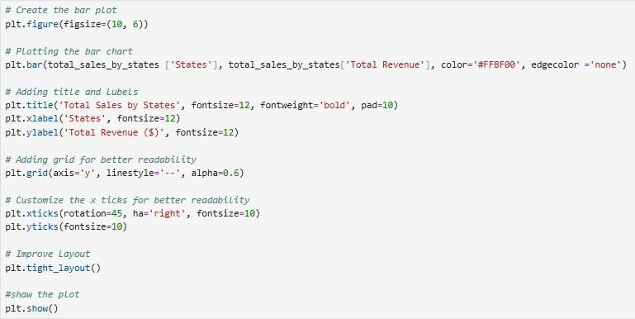

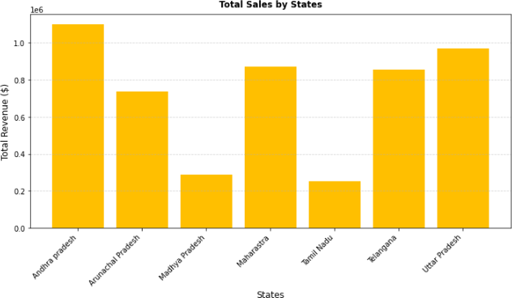

#### INTERPETATION

This bar graph shows the total sales in dollars for different states. **Andhra Pradesh** has the highest sales. **Madhya Pradesh** and **Tamil Nadu** have the lowest sales. Other states like **Maharashtra** and **Uttar Pradesh** have moderate sales..

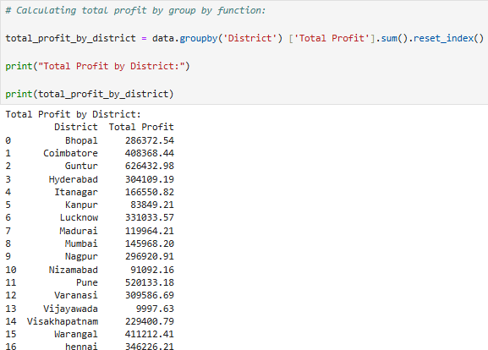

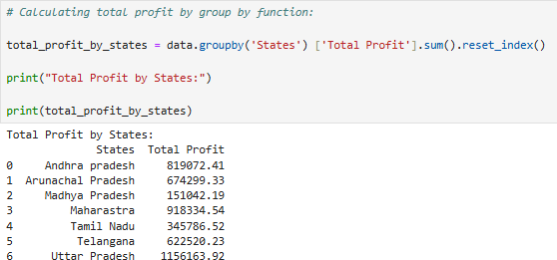

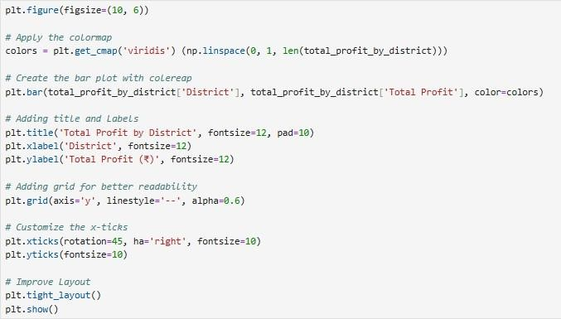

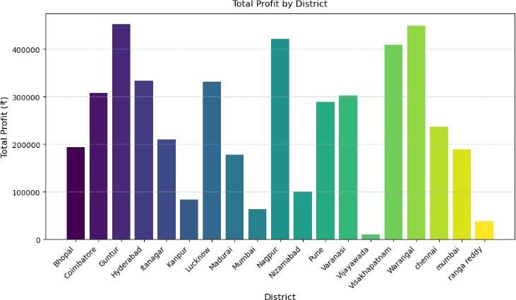

#### INTERPETATION

This bar graph shows the total profit in rupees for different districts. Some districts, like **Guntur** and **Warangal**, have much higher profits than others. Districts like **Vijayawada** and **ranga reedy** show very low profits. The colors on the bars help show which districts have the highest and lowest profits.

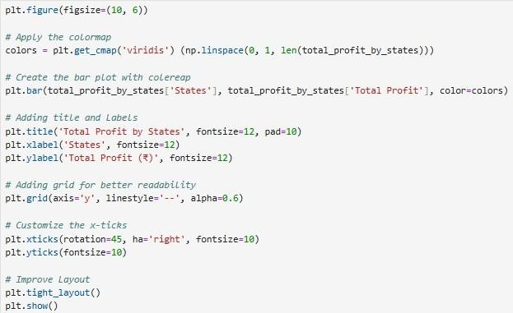

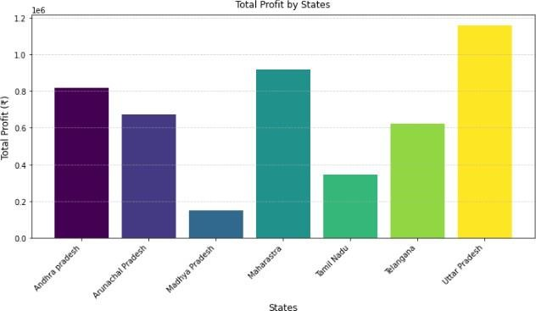

#### INTERPETATION

This bar graph shows the total profit in Indian Rupees for different states. **Uttar Pradesh** has the highest profit. **Madhya Pradesh** has the lowest profit. Other states like **Maharashtra** and **Andhra Pradesh** have moderate profits. The colours help show the differences in profit amounts.

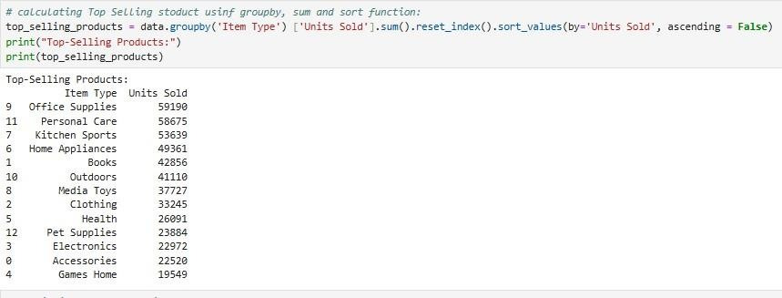

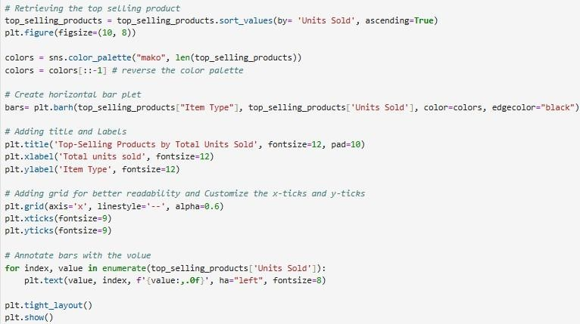

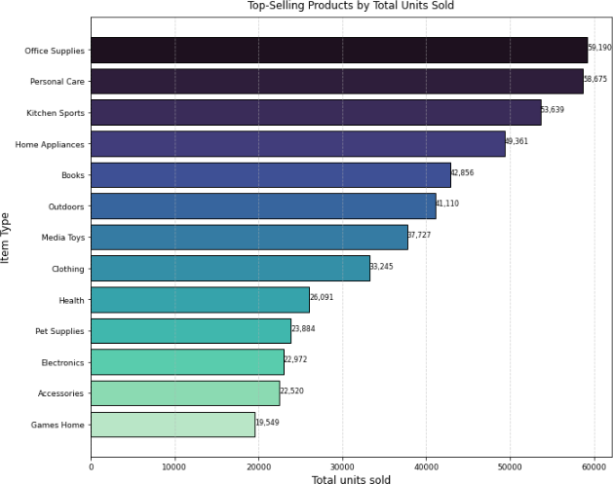

#### INTERPETATION

This bar graph shows the top-selling products by the number of units sold. Office supplies are the top-selling item. **Personal care** and **kitchen sports** are also popular. **Pet supplies** and **electronics** have the lowest sales. The graph shows a clear difference in sales between the top and bottom selling items.

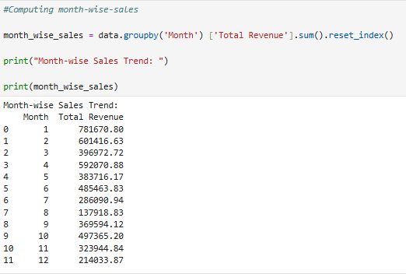

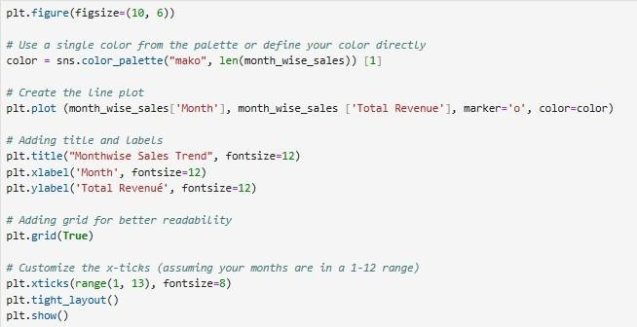

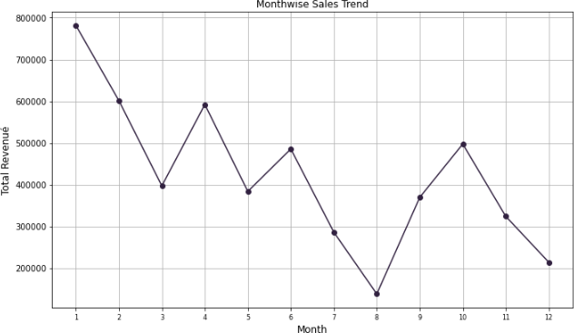

#### INTERPETATION:

The line chart represents the month-wise sales trend, showing **high revenue in January**, followed by a **decline until March**. Sales then fluctuate, peaking again in **April, June, and October**, but dropping significantly in **August**, which records the lowest revenue. There is a slight recovery in **September and October**, followed by another decline towards **December**. This trend suggests **seasonal variations in sales**, with possible external factors like demand fluctuations or market conditions affecting performance.

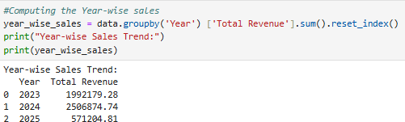

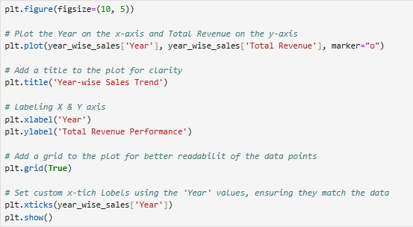

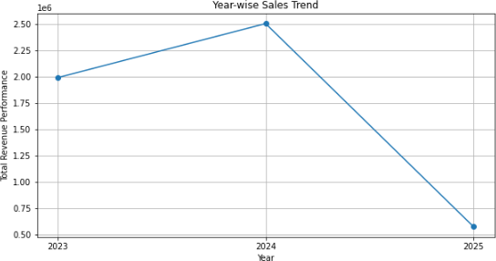

#### INTERPETATION :

The line graph shows the **year-wise sales trend**, where **revenue increased from 2023 to 2024**, reaching its highest point in **2024**. However, there is a **sharp decline in 2025**, indicating a significant drop in sales performance. This suggests that while sales were growing initially, **market challenges, reduced demand, or other factors** might have caused a major decline in 2025.

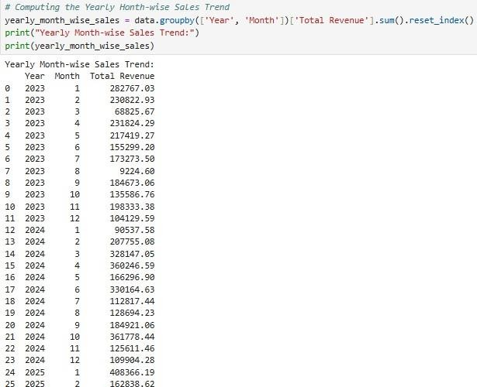

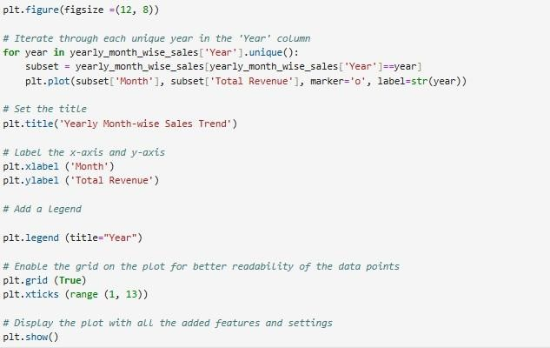

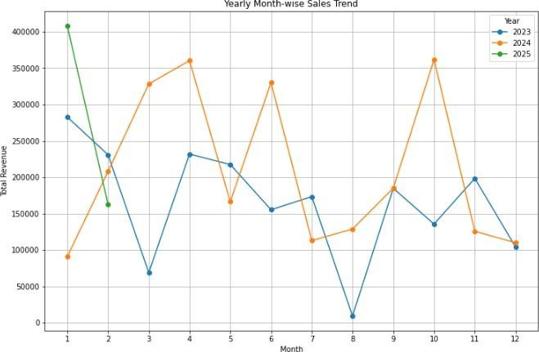

#### INTERPETATION :

The graph illustrates the **month-wise sales trend for 2023, 2024, and 2025**. Sales in **2024 (orange line) were consistently higher** compared to 2023 (blue line), showing multiple peaks and strong performance. However, **2025 (green line) has data for only the first two months**, with an initial high point in January followed by a decline in February. The **2023 trend was volatile**, with fluctuations throughout the year. The overall trend suggests **strong sales growth in 2024**, but **2025's early decline** might indicate a slowdown.

# CHAPTER – V FINDINGS, SUGGESTIONS

**& CONCLUSION**

#### 5.1 FINDINGS

* Sales vary significantly across districts and states, with some areas showing high sales and profits while others lag.
* There are seasonal trends in Amazon sales, with peaks in certain months and declines in others.
* Office supplies and personal care products are among the top-selling items.
* Sales increased from 2023 to 2024 but showed a sharp decline in 2025.
* Amazon's sales trends indicate the need for strategies to address fluctuations and improve performance in certain categories.
* The analysis uses tools like Python and techniques like trend analysis and data visualization to understand Amazon's sales patterns.
* The study is limited to Amazon India, a selection of states, and a specific time period (2023-2025).

#### 5.2 SUGGESTIONS:

* Introduce targeted promotions during low sales months to maintain consistent sales.
* Focus on strong-selling product categories while improving marketing for weaker ones.
* Prepare for peak sales seasons with better inventory management and logistics.
* Analyze competitor strategies to understand market changes and adjust pricing or marketing.
* Collect data over a longer period for better forecasting and trend analysis.
* Use data-driven insights to help Amazon grow and increase profits.

#### 5.3 CONCLUSION:

The trend analysis of Amazon sales highlights dynamic shifts in customer demand, seasonal influences, and category-wise sales variations. While the platform maintains strong performance in certain categories, a decline in sales in 2025 suggests the need for improved marketing, competitive strategies, and product diversification. Implementing data-driven insights can help Amazon sustain growth and optimize profitability.

Bibliography

* Chaffey, D. (2022). *Digital Marketing: Strategy, Implementation and Practice*

(8th ed.). Pearson Education.

* E-commerce Industry in India. (2023). *India Brand Equity Foundation (IBEF)*. Retrieved from [https://www.ibef.org](https://www.ibef.org/)
* KPMG. (2022). *Online Retail in India: The Big Leap*. KPMG India Report.
* Statista. (2023). *E-commerce Market in India – Key Trends & Figures*. Retrieved from [https://www.statista.com](https://www.statista.com/)
* Amazon India. (2023). *Annual Sales Report*. Retrieved from [https://www.amazon.in](https://www.amazon.in/)
* Kotler, P., Keller, K. L., Koshy, A., & Jha, M. (2021). *Marketing Management: A South Asian Perspective* (16th ed.). Pearson Education.
* PwC India. (2022). *Indian E-commerce Market Growth Report*. PricewaterhouseCoopers.
* Google & Bain & Company. (2023). *E-commerce Trends in India: A Data- Driven Study*.